Provisioning Report
ASAP 7.0.2 – JAMU66
&
ASAP7.0.2 – WASS1133

Month: July

August 01st, 2018
Content

1. Summary Transaction Information from JAMU66 3
2. Summary Transaction Information from WASS1133 6
3. Tickets 9
4. Platforms refusing connectivity 12
5. RFC support 14

Summary Transaction Information from JAMU66

JAMU66
Transactions |  | 365,869 | 100%
Start Date |  | 01-July-2018 00:00:00 AM
End Date |  | 31-July-2018 23:59:59 PM
Order Status | Description | Values
COMPLETED | The order was completed with successful response from the Network Element | 330,231 | 89.29%
FAILED | The order was completed with error response from the Network Element | 28,038 | 7.44%
IN_PROG | Orders in Progress | 0 | 0.00%
TIMEOUT | Orders that exceeded the execution time | 7,600 | 3.27%
TRANSL_FAIL | Orders that were not executed | 0 | 0.00%

Day | Total | Transactions  Complete | %  Complete | Transactions  Failed | %  Failed | Transactions  In_Prog | %  In_Prog | Transactions  Timeout | %  Timeout | Transactions  Trans Fail | %  Trans Fail
7/1/18 | 2,003 | 1,728 | 86.27% | 85 | 4.24% | 0 | 0.00% | 190 | 9.49% | 0 | 0.00%
7/2/18 | 26,597 | 23,589 | 88.69% | 2,290 | 8.61% | 0 | 0.00% | 718 | 2.70% | 0 | 0.00%
7/3/18 | 11,736 | 10,164 | 86.61% | 1,320 | 11.25% | 0 | 0.00% | 252 | 2.15% | 0 | 0.00%
7/4/18 | 14,513 | 12,950 | 89.23% | 1,325 | 9.13% | 0 | 0.00% | 238 | 1.64% | 0 | 0.00%
7/5/18 | 12,652 | 10,929 | 86.38% | 1,492 | 11.79% | 0 | 0.00% | 231 | 1.83% | 0 | 0.00%
7/6/18 | 10,280 | 8,996 | 87.51% | 1,101 | 10.71% | 0 | 0.00% | 183 | 1.78% | 0 | 0.00%
7/7/18 | 6,343 | 5,435 | 85.69% | 631 | 9.95% | 0 | 0.00% | 277 | 4.37% | 0 | 0.00%
7/8/18 | 1,811 | 1,504 | 83.05% | 123 | 6.79% | 0 | 0.00% | 184 | 10.16% | 0 | 0.00%
7/9/18 | 4,578 | 4,163 | 90.93% | 398 | 8.69% | 0 | 0.00% | 17 | 0.37% | 0 | 0.00%
7/10/18 | 3,567 | 3,029 | 84.92% | 517 | 14.49% | 0 | 0.00% | 21 | 0.59% | 0 | 0.00%
7/11/18 | 13,591 | 12,407 | 91.29% | 1,041 | 7.66% | 0 | 0.00% | 143 | 1.05% | 0 | 0.00%
7/12/18 | 15,298 | 13,540 | 88.51% | 1,015 | 6.63% | 0 | 0.00% | 743 | 4.86% | 0 | 0.00%
7/13/18 | 9,909 | 9,016 | 90.99% | 659 | 6.65% | 0 | 0.00% | 234 | 2.36% | 0 | 0.00%
7/14/18 | 4,104 | 3,623 | 88.28% | 300 | 7.31% | 0 | 0.00% | 181 | 4.41% | 0 | 0.00%
7/15/18 | 2,150 | 1,895 | 88.14% | 71 | 3.30% | 0 | 0.00% | 184 | 8.56% | 0 | 0.00%
7/16/18 | 14,003 | 12,615 | 90.09% | 1,136 | 8.11% | 0 | 0.00% | 252 | 1.80% | 0 | 0.00%
7/17/18 | 10,256 | 9,312 | 90.80% | 733 | 7.15% | 0 | 0.00% | 211 | 2.06% | 0 | 0.00%
7/18/18 | 16,009 | 14,491 | 90.52% | 1,309 | 8.18% | 0 | 0.00% | 209 | 1.31% | 0 | 0.00%
7/19/18 | 15,976 | 14,713 | 92.09% | 1,059 | 6.63% | 0 | 0.00% | 204 | 1.28% | 0 | 0.00%
7/20/18 | 15,147 | 14,128 | 93.27% | 803 | 5.30% | 0 | 0.00% | 216 | 1.43% | 0 | 0.00%
7/21/18 | 7,537 | 6,894 | 91.47% | 417 | 5.53% | 0 | 0.00% | 226 | 3.00% | 0 | 0.00%
7/22/18 | 1,998 | 1,670 | 83.58% | 62 | 3.10% | 0 | 0.00% | 266 | 13.31% | 0 | 0.00%
7/23/18 | 17,515 | 16,229 | 92.66% | 1,066 | 6.09% | 0 | 0.00% | 220 | 1.26% | 0 | 0.00%
7/24/18 | 15,040 | 14,026 | 93.26% | 790 | 5.25% | 0 | 0.00% | 224 | 1.49% | 0 | 0.00%
7/25/18 | 15,240 | 13,883 | 91.10% | 1,076 | 7.06% | 0 | 0.00% | 281 | 1.84% | 0 | 0.00%
7/26/18 | 22,313 | 20,748 | 92.99% | 1,343 | 6.02% | 0 | 0.00% | 222 | 0.99% | 0 | 0.00%
7/27/18 | 19,045 | 17,570 | 92.26% | 1,246 | 6.54% | 0 | 0.00% | 229 | 1.20% | 0 | 0.00%
7/28/18 | 6,663 | 5,777 | 86.70% | 634 | 9.52% | 0 | 0.00% | 252 | 3.78% | 0 | 0.00%
7/29/18 | 2,877 | 2,571 | 89.36% | 82 | 2.85% | 0 | 0.00% | 224 | 7.79% | 0 | 0.00%
7/30/18 | 28,537 | 25,656 | 89.90% | 2,633 | 9.23% | 0 | 0.00% | 248 | 0.87% | 0 | 0.00%
7/31/18 | 18,581 | 16,980 | 91.38% | 1,281 | 6.89% | 0 | 0.00% | 320 | 1.72% | 0 | 0.00%
SUMMARY  AVERAGE | 365,869 | 330,231 | 89.29% | 28,038 | 7.44% | 0 | 0.00% | 7,600 | 3.27% | 0 | 0.00%

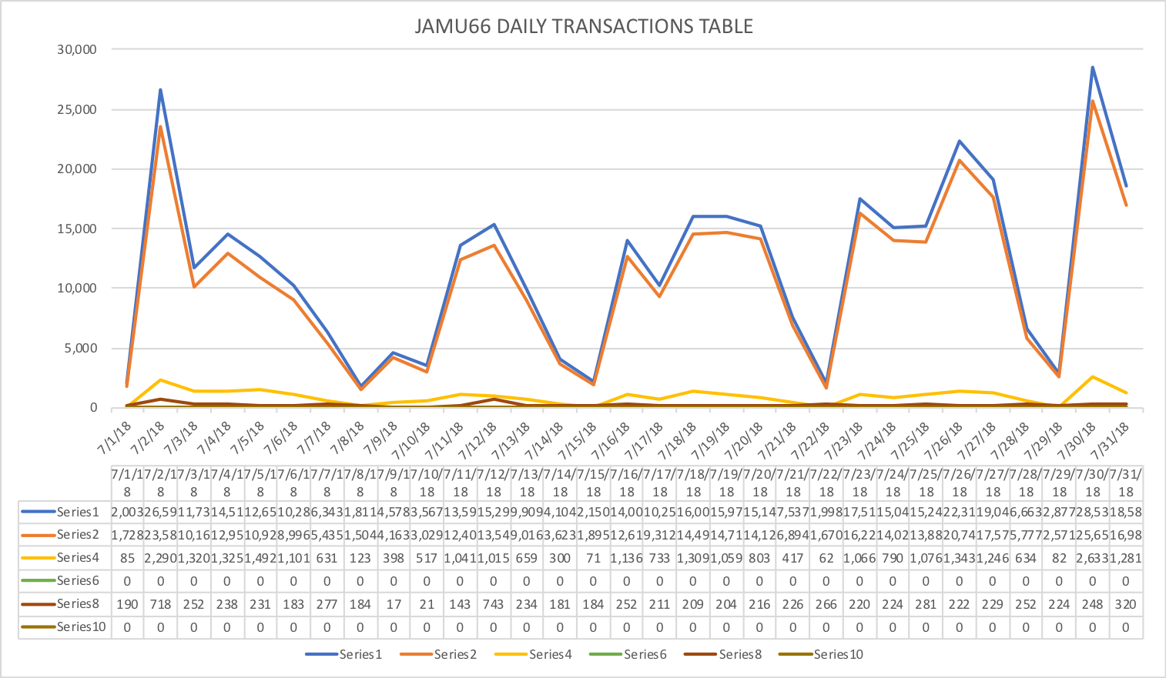

Summary Transaction Information from WASS1133

WASS1133 |  |  | %
Transactions |  | 57,448 | 100%
Start Date |  | 01-July-2018 00:00:00 AM
End Date |  | 31-July-2018 23:59:59 PM
Order Status | Description | Values
COMPLETED | The order was completed with successful response from the Network Element | 51,830 | 85.62%
FAILED | The order was completed with error response from the Network Element | 5,120 | 13.91%
IN_PROG | Orders in Progress | 0 | 0.00%
TIMEOUT | Orders that exceeded the execution time | 498 | 0.47%
TRANSL_FAIL | Orders that were not executed | 0 | 0.00%

Day | Total | Transactions  Complete | %  Complete | Transactions  Failed | %  Failed | Transactions  In_Prog | %  In_Prog | Transactions  Timeout | %  Timeout | Transactions  Trans Fail | %  Trans Fail
7/1/18 | 125 | 97 | 77.60% | 28 | 22.40% | 0 | 0.00% | 0 | 0.00% | 0 | 0.00%
7/2/18 | 1,399 | 1069 | 76.41% | 314 | 22.44% | 0 | 0.00% | 16 | 1.14% | 0 | 0.00%
7/3/18 | 1,061 | 967 | 91.14% | 82 | 7.73% | 0 | 0.00% | 12 | 1.13% | 0 | 0.00%
7/4/18 | 2,836 | 2705 | 95.38% | 126 | 4.44% | 0 | 0.00% | 5 | 0.18% | 0 | 0.00%
7/5/18 | 1,576 | 1492 | 94.67% | 76 | 4.82% | 0 | 0.00% | 8 | 0.51% | 0 | 0.00%
7/6/18 | 847 | 771 | 91.03% | 73 | 8.62% | 0 | 0.00% | 3 | 0.35% | 0 | 0.00%
7/7/18 | 262 | 244 | 93.13% | 18 | 6.87% | 0 | 0.00% | 0 | 0.00% | 0 | 0.00%
7/8/18 | 8 | 7 | 87.50% | 1 | 12.50% | 0 | 0.00% | 0 | 0.00% | 0 | 0.00%
7/9/18 | 8,300 | 7493 | 90.28% | 678 | 8.17% | 0 | 0.00% | 129 | 1.55% | 0 | 0.00%
7/10/18 | 17,596 | 16513 | 93.85% | 906 | 5.15% | 0 | 0.00% | 177 | 1.01% | 0 | 0.00%
7/11/18 | 4,116 | 3875 | 94.14% | 162 | 3.94% | 0 | 0.00% | 79 | 1.92% | 0 | 0.00%
7/12/18 | 805 | 735 | 91.30% | 68 | 8.45% | 0 | 0.00% | 2 | 0.25% | 0 | 0.00%
7/13/18 | 773 | 683 | 88.36% | 84 | 10.87% | 0 | 0.00% | 6 | 0.78% | 0 | 0.00%
7/14/18 | 269 | 253 | 94.05% | 16 | 5.95% | 0 | 0.00% | 0 | 0.00% | 0 | 0.00%
7/15/18 | 15 | 9 | 60.00% | 6 | 40.00% | 0 | 0.00% | 0 | 0.00% | 0 | 0.00%
7/16/18 | 458 | 342 | 74.67% | 114 | 24.89% | 0 | 0.00% | 2 | 0.44% | 0 | 0.00%
7/17/18 | 1,258 | 1052 | 83.62% | 202 | 16.06% | 0 | 0.00% | 4 | 0.32% | 0 | 0.00%
7/18/18 | 2,496 | 2140 | 85.74% | 352 | 14.10% | 0 | 0.00% | 4 | 0.16% | 0 | 0.00%
7/19/18 | 1,965 | 1810 | 92.11% | 150 | 7.63% | 0 | 0.00% | 5 | 0.25% | 0 | 0.00%
7/20/18 | 880 | 739 | 83.98% | 131 | 14.89% | 0 | 0.00% | 10 | 1.14% | 0 | 0.00%
7/21/18 | 195 | 169 | 86.67% | 25 | 12.82% | 0 | 0.00% | 1 | 0.51% | 0 | 0.00%
7/22/18 | 9 | 5 | 55.56% | 4 | 44.44% | 0 | 0.00% | 0 | 0.00% | 0 | 0.00%
7/23/18 | 1,040 | 758 | 72.88% | 271 | 26.06% | 0 | 0.00% | 11 | 1.06% | 0 | 0.00%
7/24/18 | 2,665 | 2422 | 90.88% | 237 | 8.89% | 0 | 0.00% | 6 | 0.23% | 0 | 0.00%
7/25/18 | 1,067 | 869 | 81.44% | 195 | 18.28% | 0 | 0.00% | 3 | 0.28% | 0 | 0.00%
7/26/18 | 2,374 | 2015 | 84.88% | 352 | 14.83% | 0 | 0.00% | 7 | 0.29% | 0 | 0.00%
7/27/18 | 811 | 669 | 82.49% | 142 | 17.51% | 0 | 0.00% | 0 | 0.00% | 0 | 0.00%
7/28/18 | 220 | 196 | 89.09% | 23 | 10.45% | 0 | 0.00% | 1 | 0.45% | 0 | 0.00%
7/29/18 | 5 | 5 | 100.00% | 0 | 0.00% | 0 | 0.00% | 0 | 0.00% | 0 | 0.00%
7/30/18 | 995 | 888 | 89.25% | 104 | 10.45% | 0 | 0.00% | 3 | 0.30% | 0 | 0.00%
7/31/18 | 1,022 | 838 | 82.00% | 180 | 17.61% | 0 | 0.00% | 4 | 0.39% | 0 | 0.00%
SUMMARY  AVERAGE | 57,448 | 51,830 | 85.62% | 5,120 | 13.91% | 0 | 0.00% | 498 | 0.47% | 0 | 0.00%

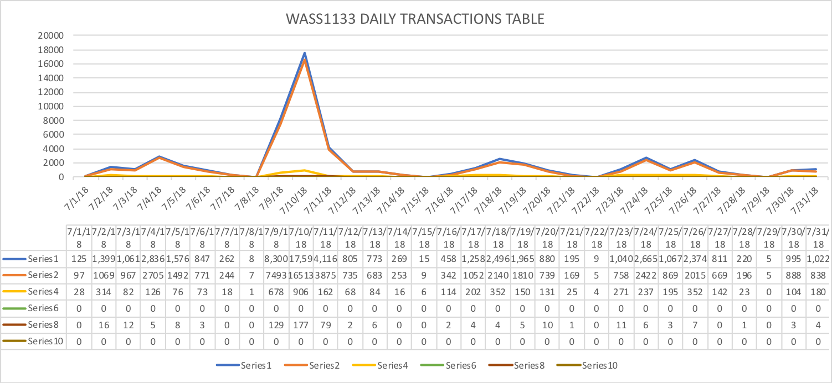

Tickets
June Statistics
Tickets | 32
Severity
LOW | 19
MEDIUM | 9
HIGH | 4
Origin
asap.support | 13
Chinnasani Prasanna | 1
Joy | 1
Madhusudhan Adapala | 3
Neilsa | 4
Praneetah | 3
Samantha | 1
Shivanchyut | 1
Shivanchyut Baghel | 1
Suresh | 1
Connection Refused | 3

Accumulative
Tickets | 180
Severity
LOW | 74
MEDIUM | 38
HIGH | 36
Origin
Abhijit | 1
asap.support | 13
Barbara | 2
Chinnasani | 5
Chinnasani Prasanna | 1
FLOW IT AUTOMATED PROVISIONING | 1
Harish, Prakash | 2
IGATE LIBERATE TIER 2 SUPPORT | 1
Jason | 1
Joy | 16
Juan Pablo | 4
Kishore | 13
León | 1
Madhusudhan | 1
Madhusudhan Adapala | 3
Marcia | 1
Mark | 2
Mora | 1
Mounika | 12
Neilsa | 103
Nola | 2
Prakash | 14
Praneetha | 13
Rhonda | 2
Rosaline | 1
Samantha | 5
Shalana | 3
Shivanchyut | 1
Shivanchyut Baghel | 1
Suresh | 3
Terry | 1
Uday | 2
Wendy | 1
Connection Refused | 44

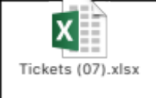

Platforms refusing connectivity

CONNECTION REFUSE E-MAIL TITLE | DATE | STATUS
ASAP monitor; connection refused SLU_UVF | 24/1/18 | CLOSED
ASAP monitor; connection refused EST_GSAT & EST_GSAT1 | 25/1/18 | OPEN
ASAP monitor; connection refused SLU_UVF | 30/1/18 | CLOSED
ASAP monitor; connection refused SLU_UVF | 2/2/18 | CLOSED
ASAP monitor; connection refused SLU_UVF | 5/2/18 | CLOSED
ASAP monitor; connection refused SLU_UVF | 6/2/18 | CLOSED
ASAP monitor; connection refused SLU_CEN | 5/2/18 | CLOSED
ASAP monitor; connection refused SLU_UVF | 9/2/18 | CLOSED
ASAP monitor; connection refused JAM_CALIX | 13/2/18 | OPEN
ASAP monitor; connection refused SLU_UVF | 16/2/18 | CLOSED
ASAP-WASS133-ASAP There is no connection to Database -No Listener | 18/2/18 | CLOSED
ASAP JAMU66 shutdown | 22/2/18 | CLOSED
ASAP monitor; connection refused SLU_UVF | 22/2/18 | CLOSED
ASAP monitor; connection refused CAY_GNBND with WASS1133 | 22/2/18 | OPEN
ASAP monitor; connection refused SLU_UVF | 22/2/18 | CLOSED
ASAP monitor; connection refused SLU_UVF | 28/2/18 | CLOSED
WASS1133-ASAP provisioning asappro1 user fails to login | 28/2/18 | CLOSED
ASAP monitor; connection refused SLU_CEN | 5/3/18 | CLOSED
JAM_MOBY connection failure | 9/3/18 | CLOSED
ASAP-FLOW-monitor, Unable to connect to remote host: Connection refused to SLU_UVF | 13/3/18 | CLOSED
ASAP monitor; connection refused SLU_UVF | 14/3/18 | CLOSED
ASAP monitor; connection refused SLU_UVF | 28/3/18 | CLOSED
ASAP monitor; connection refused SLU_UVF | 2/4/18 | CLOSED
ASAP monitor; connection refused SLU_UVF | 3/4/18 | CLOSED
ASAP monitor; connection refused JAM_EAST | 3/4/18 | CLOSED
ASAP monitor; connection refused SLU_UVF | 5/4/18 | CLOSED
ASAP monitor; connection refused SLU_UVF | 9/4/18 | CLOSED
ASAP connection refused SONUS | 11/4/18 | CLOSED
ASAP connection refused SONUS | 16/4/18 | CLOSED
ASAP monitor; connection refused SLU_UVF | 16/4/18 | CLOSED
ASAP monitor; connection refused SLU_UVF | 26/4/18 | CLOSED
ASAP monitor; connection refused SLU_CEN | 26/4/18 | CLOSED
ASAP monitor; connection refused SLU_UVF | 30/4/18 | OPEN
ASAP monitor; connection refused SLU_UVF | 2/5/18 | CLOSED
LIME-ASAP-jamu66-Connection Fail to SONUS platform | 28/5/18 | CLOSED
ASAP monitor; connection refused SLU_UVF | 11/06/18 | CLOSED
ASAP monitor; connection refused SLU_UVF | 11/06/18 | CLOSED
ASAP monitor; connection refused SLU_UVF and SLU_CEN | 19/06/18 | CLOSED
ASAP monitor; connection refused SLU_UVF and SLU_CEN | 21/06/18 | CLOSED
ASAP-Route Activation traffic to wass1133 | 24/06/18 | CLOSED
ASAP monitor; connection refused SLU_UVF | 03/07/18 | CLOSED
ASAP monitor; connection refused SLU_UVF | 04/07/18 | CLOSED
ASAP monitor; connection refused SLU_UVF | 23/07/18 | CLOSED

RFC support

CONCEPT | DATE
RFC 4080434 - Barbados HLR CP Upgrade from R12B to R15A | 25/01/2018
|RFC6786| SCHEDULED RFC NOTIFICATION Cleandata Routine Maintenance on JAMU66 | 22/02/2018
RFC6955-Reroute provisioning on Barbados HLR to Jamaica HLR - MW3 | 7/03/2018
|RFC7430| SCHEDULED RFC NOTIFICATION Routine Maintenance: ASAP Cleandata on JAMU66 server | 11/04/2018
|RFC8041| SCHEDULED RFC NOTIFICATION ASAP Cleandata Maintenance Activity - JAMU66 | 24/05/2018

